Lab 2

ECN - 252

19114001 Abhinav Saini

**Part – 1**  Full Adder

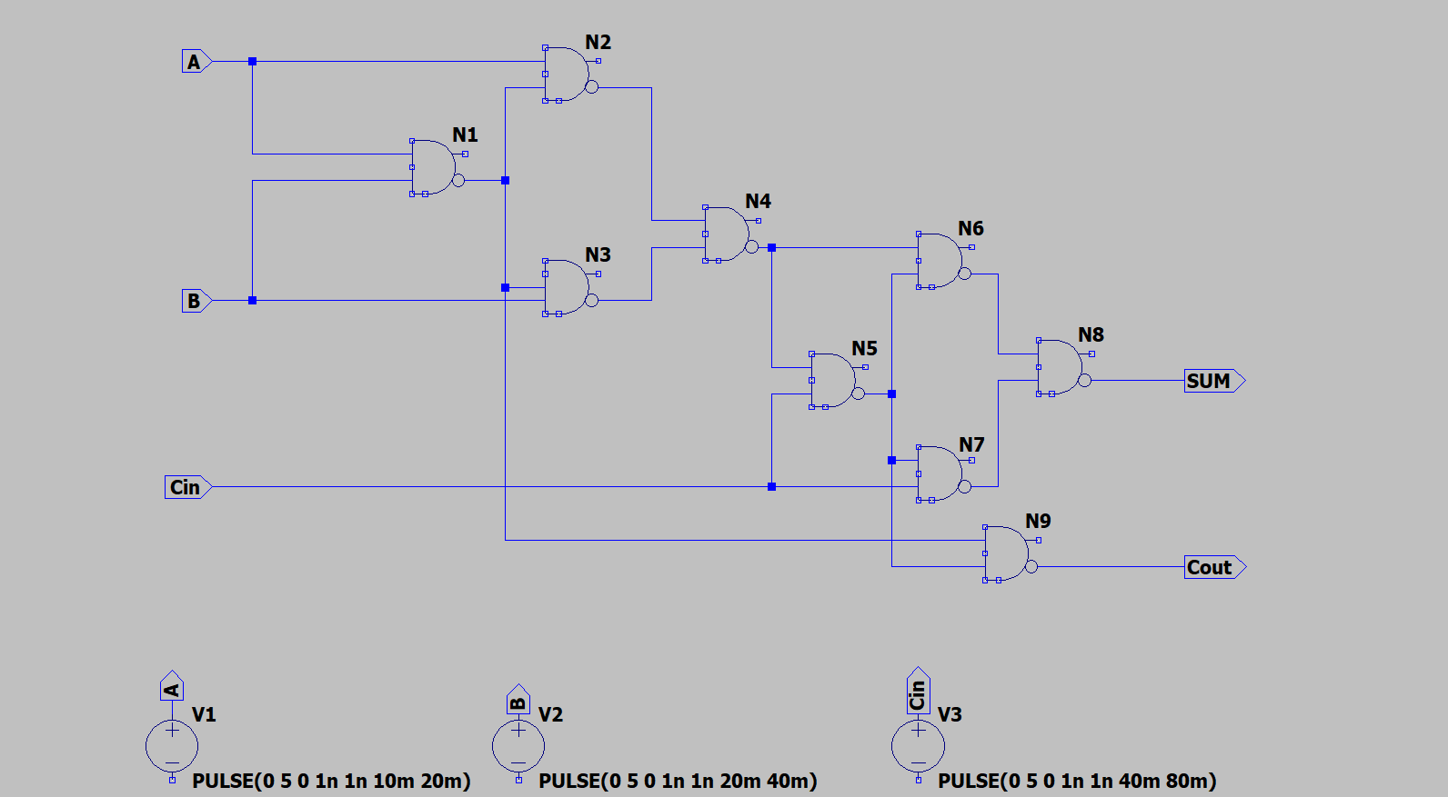Schematic

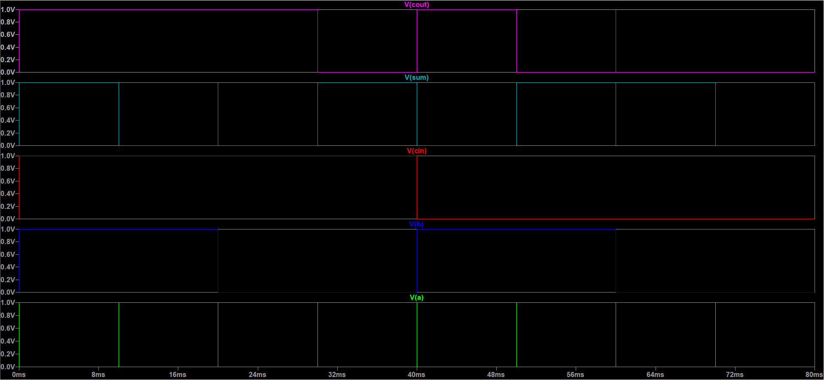Simulation

**Part – 2** 4-bit adder

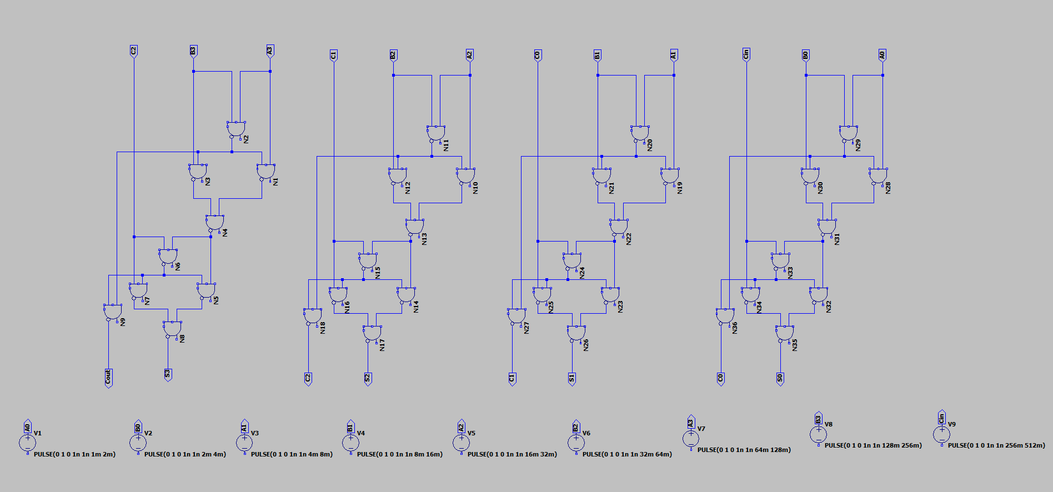Schematic

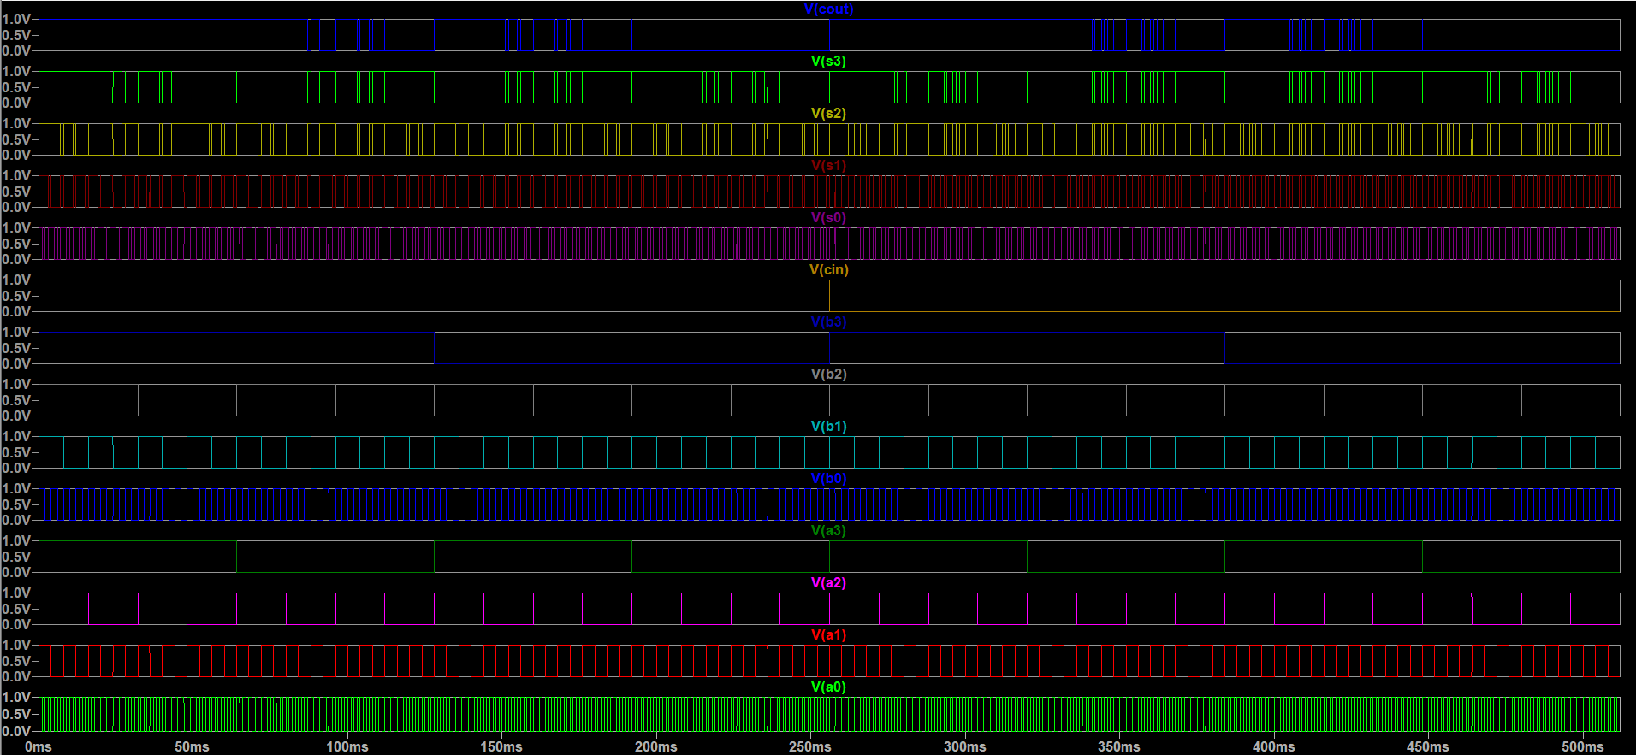Simulation

**Part – 3** A = 1011 B = 0111, S = 0100

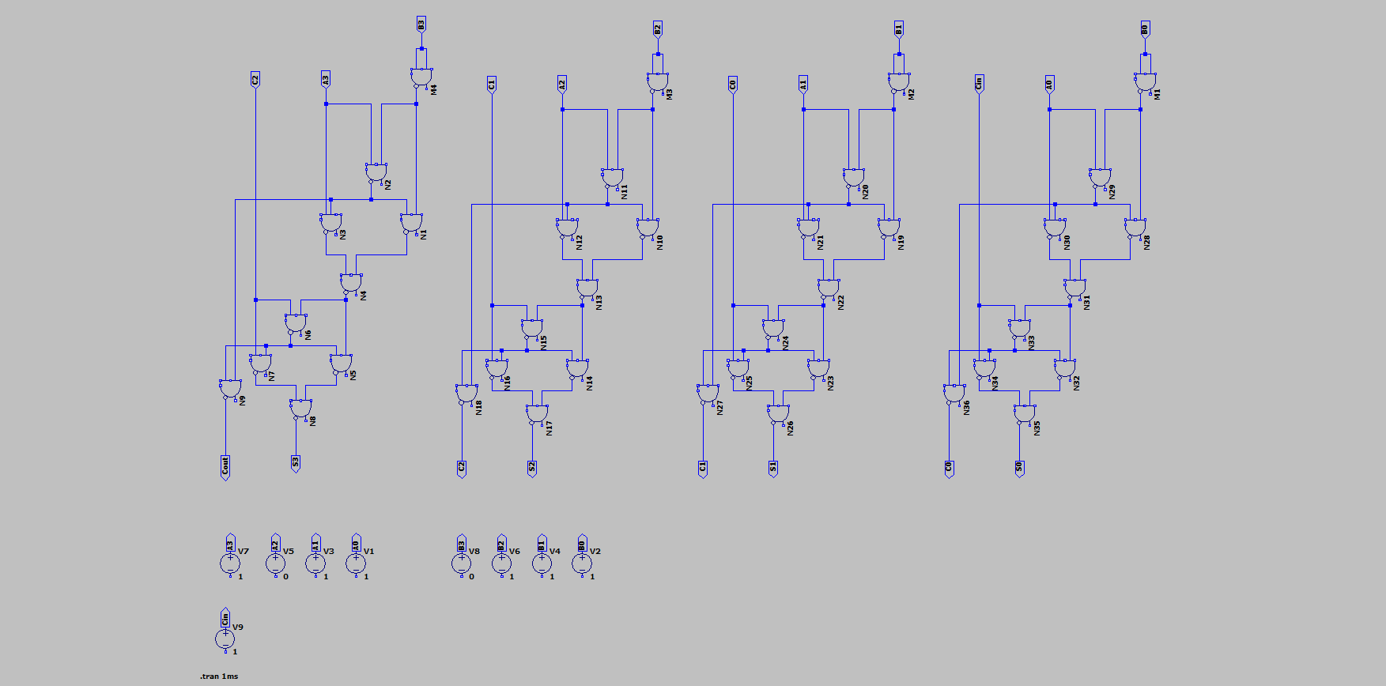Schematic

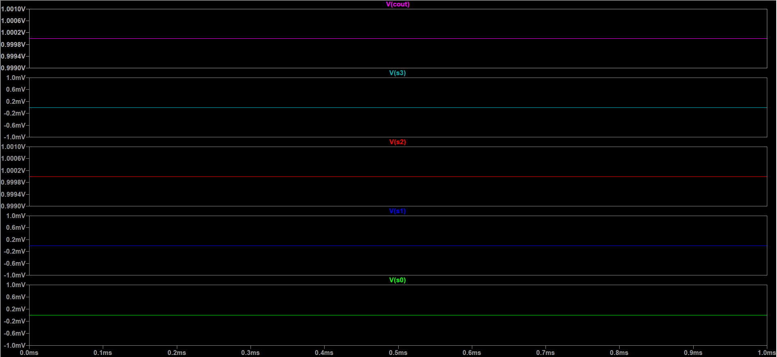Simulation